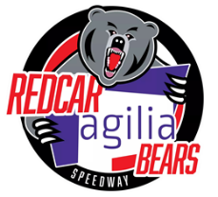
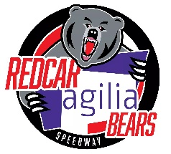
Redcar Agilia Bears Speedway
South Tees Motor Sports Park, South Bank Road, Middlesbrough, TS6 6XH

Promoters: Jamie Swales Email jswales.redcarbears@gmail.com
Jade Mudgway Email jmudgway.redcarbears@gmail.com
2022 Season Ticket Application

Includes – All League, 1st round KO Cup, New Summer , Julie Lewis Memorial and Tyne-Tees Trophy (16 matches)
20% discount on Play Off’s, KO Cup rounds & Silver Helmet, 10% discount on merchandise
Excludes – Testimonials and BSPA Shared Events

Prices
Adult £260
Concession £230 (Students & over 65’s)
Child £15 (Under 16’s)

Please complete the form below. Detach and return to the above address or scan and email. Your season card will be available to collect from the turnstiles at the first meeting
_ _ _ _ _ _ _ _ _ _ _ _ _ _ _ _ _ _ _ _ _ _ _ _ _ _ _ _ _ _ _ _ _ _ _ _ _ _ _ _ _ _ _ _ _ _ _ _ _ _ _ _ _ _ _ _ _ _ _ _ _ _ _ _

Season Ticket Application
Name………………………………………………………………………………………………………………
Address……………………………………………………………………………………………………….….
………………………………………………………………………………………………….……………………
……………………………………………………………Postcode.………………………………………….
Telephone……………………………………………………………………………………………………...
Email………………………………………………………………………………………………………………
Date of Birth……………………………………………………………………………………………………
Ticket Applied For (tick box) Adult □ Concession □ Child □
Fee included £……………… Cheque/Cash (delete as appropriate)
Cheques payable to Redcar Borough Bears Ltd
Card payments can be taken at the track during any of our upcoming social evenings or email
for details of how to pay by card on-line

