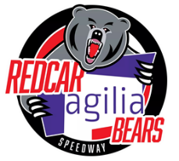
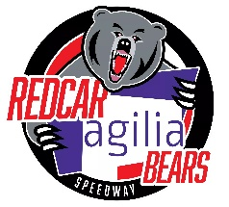
Redcar Agilia Bears Speedway
South Tees Motor Sports Park, South Bank Road, Middlesbrough, TS6 6XH

Promoters: Jamie Swales Email jswales.redcarbears@gmail.com
Jade Mudgway Email jmudgway.redcarbears@gmail.com
2022 Season Ticket Application

Includes – All League, Knock Out Cup, League Cup and Challenge Fixtures (Minimum 16 matches)
20% discount on Play Off’s & Silver Helmet, 10% discount on merchandise
Excludes – Testimonials and BSPA Shared Events

Prices
Adult £260
Concession £230 (Students & over 65’s)

Please complete the form below. Detach and return to the above address with a stamped self-addressed return envelope.
_ _ _ _ _ _ _ _ _ _ _ _ _ _ _ _ _ _ _ _ _ _ _ _ _ _ _ _ _ _ _ _ _ _ _ _ _ _ _ _ _ _ _ _ _ _ _ _ _ _ _ _ _ _ _ _ _ _ _ _ _ _ _ _

Season Ticket Application
Name……………………………………………………………………………………………………………… Member No………….
Address……………………………………………………………………………………………………….….
………………………………………………………………………………………………….……………………
……………………………………………………………Postcode.………………………………………….
Telephone……………………………………………………………………………………………………...
Email………………………………………………………………………………………………………………
Date of Birth……………………………………………………………………………………………………
Ticket Applied For (tick box) Adult □ Concession □
Fee included £……………… Cheque/Cash (delete as appropriate)
Cheques payable to Redcar Borough Bears Ltd
Card payments can be taken at the track during any of our up coming social evenings

